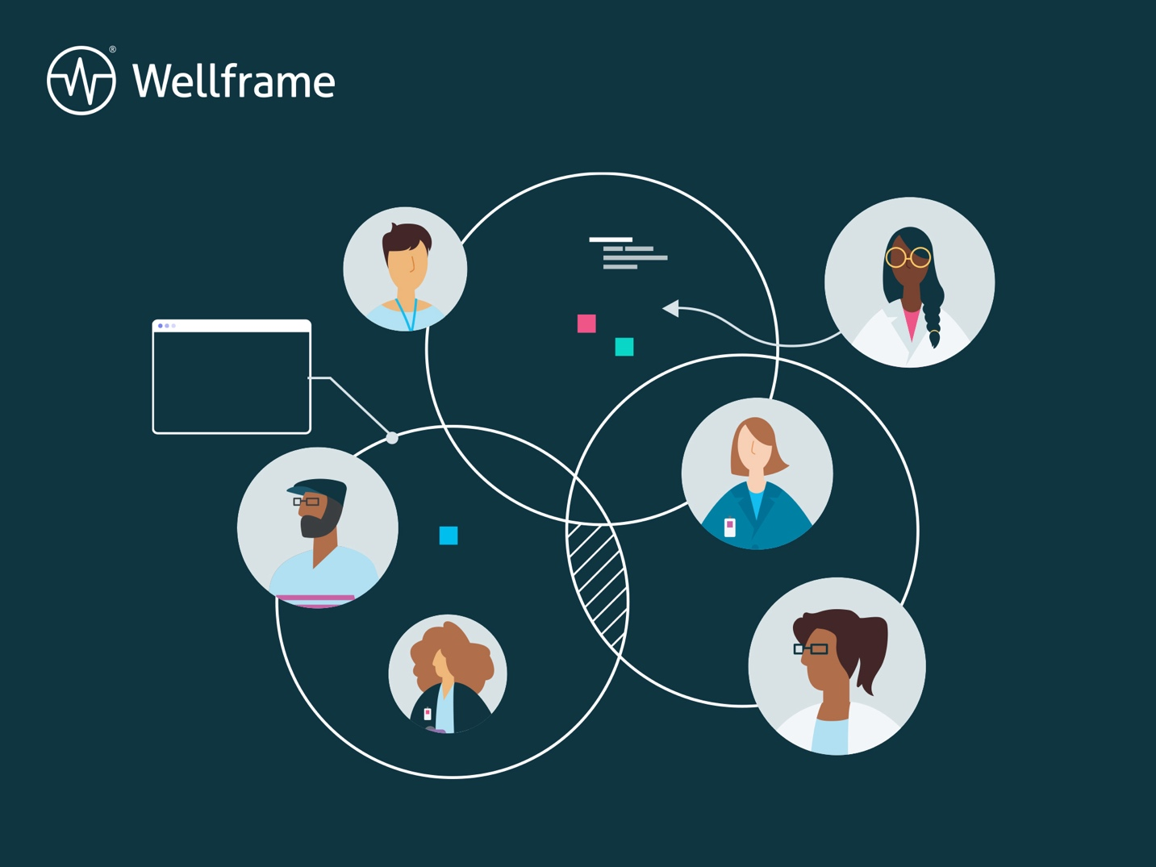

WORKBOOK

The 5-step framework for driving staff efficiency and effectiveness
Investing in a digital health strategy is only one step of a larger digital evolution journey. In order to demonstrate overall program ROI and member engagement, health plan leaders must first ensure frontline staff can use technology investments efficiently and effectively.
Complete this workbook to help guide your strategy at each stage of Wellframe’s proven staffing optimization framework.

Step 1: Assess
Observe and discover current care team design, staff members, workflows, strategies, care models, and training modalities.

Who is on your care teams today?

What are their roles?

How many members can each staff member manage?

Step 2: Diagnose
Identify problems, risks, and strengths to adopting new digital health technology

What are the challenges staff may face in using a digital health management platform? Examples may include competing communications channels or documentation requirements.

Historically, does your care team demonstrate flexibility or adaptability to change, such as new technology?

Step 3: Plan
Identify recommendations and goals for training, engagement, workflows, and staff adoption.

Does your performance management plan include digital performance metrics such as member onboarding and member engagement rates?

Do your digital workflows support top-of-license practice by your clinicians?

Step 4: Implement
Execute recommendations and goals, ensuring there is accountability from executive leadership.

Is there an engaged executive who will ensure the entire organization structure is aligned and executing on the recommended digital transformation strategy?

Step 5: Evaluate
Review data-driven outcomes and metrics to build on your success or modify plans as needed in order to continuously improve.

What does digital transformation success look like, and have you reached these goals? For example, did the initiative result in more member touchpoints or greater staff efficiency along with member adoption?

What will you adjust or reprioritize based on your evaluation?

Looking for additional guidance as you develop your staffing optimization strategy?

Request a 1:1 consultation with one of our experts.

